

**Dear Gunasuriya C,**

We hope this letter finds you well. We are writing to extend a formal offer of employment for the position of **Junior Frontend Developer** in our esteemed organization.

After careful consideration of your qualifications, skills, and internship performance, we are pleased to offer you the position of **Junior Frontend Developer** at **Mobility Intelligence Softwares**. We believe that your expertise will greatly contribute to our team and the success of our organization.

Below are the specific details regarding your employment offer:

**Position:** Junior Frontend Developer

**Salary:** **INR 2.50 LPA** (Rupees Two Lakh Fifty Thousand per annum), which is **INR 20,833 per month.** Additionally, there’s a monthly allowance of INR 5,000.

**Employment Type:** Full-Time

**Joining Date:** 15-10-2025

**Location:** Mobility Intelligence Softwares, Second Floor, 37A11, Sathy Main Road, Sivanandhapuram, Saravanampatti, Coimbatore, Tamil Nadu – 641035

This position reports to **Mr. Sasi Kumar,** Head of Senior Full Stack Developer at Mobility Intelligence Softwares, and the working hours will be from **9:00 AM to 6:00 PM**, Monday to Saturday, inclusive of a designated 1-hour lunch break.

Your probation period shall continue for a period of **six months**, beginning with the joining date.

If you experience frequent unplanned absences during your probationary period, we may need to extend this period to allow for a thorough assessment of your performance. Should this be necessary, we will inform you in writing and kindly request your acknowledgment and understanding.

Please note that the remuneration provided is inclusive of **Travel Allowance (TA)** and **Food Allowance (FA).**

We believe that you possess the necessary skills and qualifications required to excel in this role. Your contributions will play a vital part in the growth and success of our organization.

Once again, congratulations on your selection for the position of **Junior Frontend Developer** at Mobility Intelligence Softwares. We look forward to welcoming you to our team and working together to achieve great things.

Thank you for your time and consideration. We eagerly await your positive confirmation.

Best Regards,

_________________

HR Manager

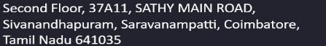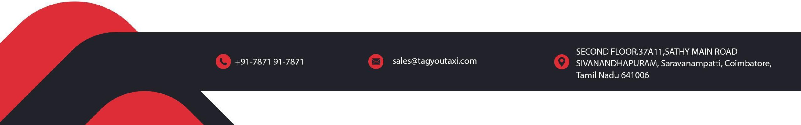Mobility Intelligence Softwares